SIMATS ENGINEERING
NAME: A.Preetika Sudhakar
RREG NO. 192371073
COURSE NAME: Database Management Systems
COURSE CODE: CSA0501
3.DML Commands – INSERT, SELECT

Aim:
To perform Data Manipulation Language (DML) Commands such as INSERT, SELECT in the table.

Description:
Data Manipulation Language (DML) statements are used for managing data within schema objects. DML
Commands: Insert, Select
➢ INSERT - insert data into a table
➢ SELECT - retrieve data from the a database
INSERT:
INSERT INTO table_name
VALUES (value1, value2, value3,...);
( or )
INSERT INTO table_name (column1, column2, column3,...)
VALUES (value1, value2, value3,...);

SELECT:
SELECT column_name(s)
FROM table_name;

Questions:
1. Populate all the five tables with your own data.
2. View all the records from the five tables.

OUTPUT:
Table 1: PLOTS
INSERT INTO plots VALUES (1,'P101',1200,1500000.00,'Available','Salem',1), (2,'P102',1500,1800000.00,'Sold','Chennai',2), (3,'P103',1000,1300000.00,'Available','Erode',1);
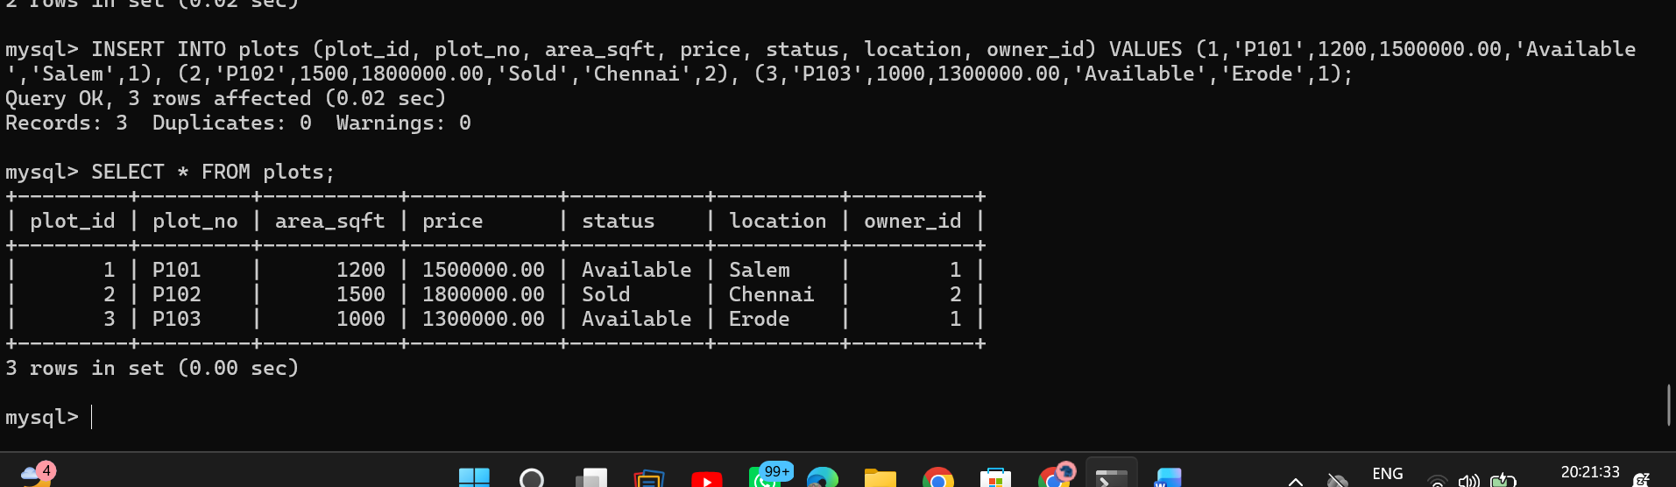

Question 2: View all the records from the five tables.
SELECT * FROM owners; SELECT * FROM plots;
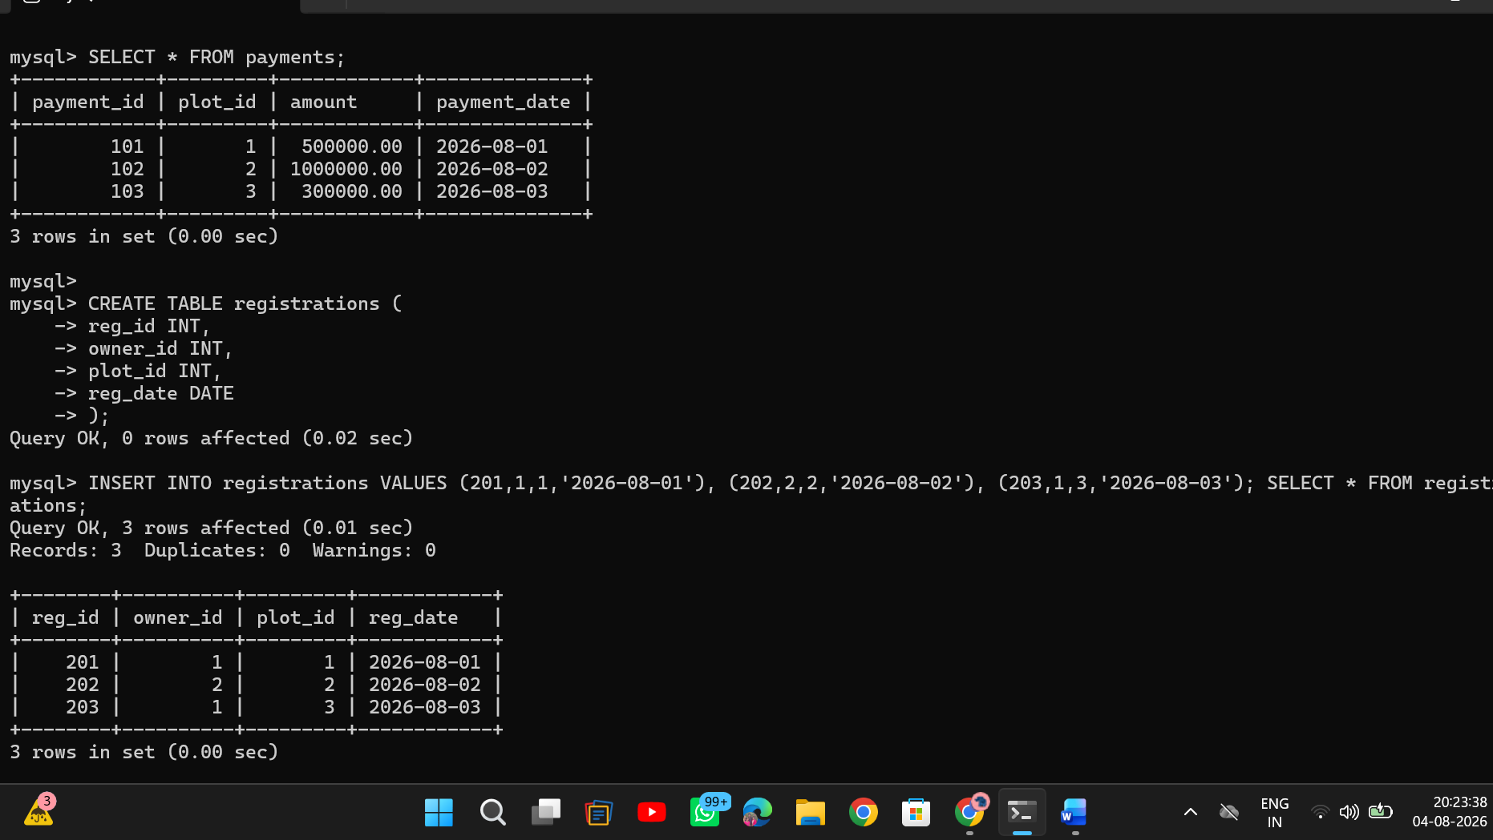
RESULT:
Data Manipulation Language (DML) Commands such as INSERT, SELECT are performed in the five tables.

